**15MH403L MECHATRONICS LABORATORY**

**EXAM 2020-2021 ODD SEMESTER**

Develop a model of a one degree of freedom joint constituting a planar mechanism as shown below, using the Foundation Library in Simscape. Incorporate a DC motor model (obtain the specifications of the DC motor from the datasheet given below for the model C23-L33 with winding code 10). Use PID controller and simulate the plant for a desired trajectory given. (Use the MATLAB PID auto tuning block)

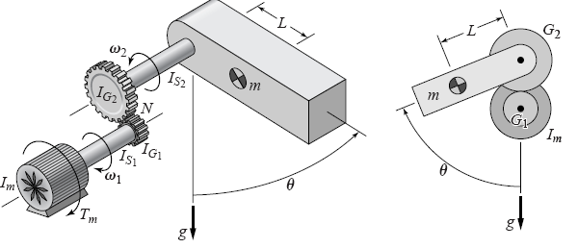

|  |  |
| --- | --- |
| **Physical Parameter** | **Specification** |
| Moment of inertia of the drive shaft, I­S1 | kg $·m^{2}$ |
| Moment of inertia of the driven shaft, IS2 | kg $·m^{2}$ |
| Gear ratio | 2 |
| Mass | 4 kg |
| Length of the link | 0.25 m |
| Acceleration due to gravity | 9.81 m/s2 |

**DESIRED TRAJECTORY:**

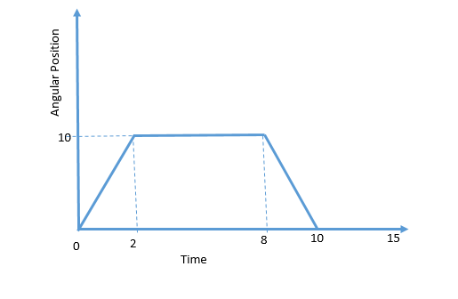

**Obtain the specifications of the DC motor from the datasheet given below for the model C23-L33 with winding code 10**

|  |  |  |  |  |  |  |  |  |  |  |  |
| --- | --- | --- | --- | --- | --- | --- | --- | --- | --- | --- | --- |
| Part Number* | | C23-L33 | | | | | C23-L40 | | | | |
| Winding Code** |  | 10 | 20 | 30 | 40 | 50 | 10 | 20 | 30 | 40 | 50 |
| L = Length | inches | 3.33 | | | | | 4 | | | | |
| millimeters | 84.6 | | | | | 101.6 | | | | |
| Peak Torque | oz-in | 125.0 | 125.0 | 125.0 | 125.0 | 125.0 | 250.0 | 250.0 | 250.0 | 250.0 | 250.0 |
| Nm | 0.883 | 0.883 | 0.883 | 0.883 | 0.883 | 1.765 | 1.765 | 1.765 | 1.765 | 1.765 |
| Continuous Stall Torque | oz-in | 16.5 | 16.5 | 16.5 | 16.5 | 16.5 | 27.0 | 27.0 | 27.0 | 27.0 | 27.0 |
| Nm | 0.117 | 0.117 | 0.117 | 0.117 | 0.117 | 0.191 | 0.191 | 0.191 | 0.191 | 0.191 |
| Rated Terminal Voltage | volts DC | 12 -24 | 12 - 24 | 12 -36 | 12 - 60 | 12 - 60 | 12 - 24 | 12 - 48 | 12 - 60 | 12 - 60 | 12 - 60 |
| Terminal Voltage | volts DC | 12 | 12 | 24 | 36 | 48 | 12 | 24 | 36 | 48 | 60 |
| Rated Speed | RPM | 4700 | 2150 | 4200 | 3750 | 3000 | 2300 | 3600 | 3500 | 2850 | 2250 |
| rad/sec | 492 | 225 | 440 | 393 | 314 | 241 | 377 | 367 | 298 | 236 |
| Rated Torque | oz-in | 7.5 | 12.6 | 12.7 | 14.4 | 15.8 | 17.3 | 25.5 | 25.3 | 25.6 | 24.2 |
| Nm | 0.05 | 0.09 | 0.09 | 0.10 | 0.11 | 0.12 | 0.18 | 0.18 | 0.18 | 0.17 |
| Rated Current | Amps | 4.75 | 4.3 | 3 | 2 | 1.4 | 4.9 | 4.3 | 2.75 | 1.8 | 1.1 |
| Rated Power | Watts | 26.1 | 20.0 | 39.5 | 40.0 | 35.1 | 29.4 | 67.9 | 65.5 | 54.0 | 40.3 |
| Horsepower | 0.03 | 0.03 | 0.05 | 0.05 | 0.05 | 0.04 | 0.09 | 0.09 | 0.07 | 0.05 |
| Torque Senstivity | oz-in/amp | 2.65 | 4.25 | 6.2 | 10.25 | 15.75 | 4.84 | 7.74 | 12 | 18.5 | 28.75 |
| Nm/amp | 0.0187 | 0.0300 | 0.0438 | 0.0724 | 0.1112 | 0.0342 | 0.0547 | 0.0847 | 0.1306 | 0.2030 |
| Back EMF | volts/KRPM | 2 | 3.15 | 4.6 | 7.6 | 11.5 | 3.58 | 5.72 | 8.82 | 13.82 | 21.22 |
| volts/rad/sec | 0.0191 | 0.0301 | 0.0439 | 0.0726 | 0.1098 | 0.0342 | 0.0546 | 0.0842 | 0.1320 | 0.2026 |
| Terminal Resistance | ohms | 0.60 | 1.00 | 1.70 | 4.00 | 9.00 | 0.70 | 0.96 | 2.30 | 5.50 | 12.00 |
| Terminal Inductance | mH | 0.35 | 0.94 | 2.00 | 5.50 | 13.00 | 0.50 | 1.30 | 3.10 | 7.36 | 18.00 |
| Motor Constant | oz-in/watt^1/2 | 3.4 | 4.3 | 4.8 | 5.1 | 5.3 | 5.8 | 7.9 | 7.9 | 7.9 | 8.3 |
| Nm/watt | 0.024 | 0.030 | 0.034 | 0.036 | 0.037 | 0.041 | 0.056 | 0.056 | 0.056 | 0.059 |
| Rotor Inertia | oz-in-sec2 | 0.0022 | 0.0022 | 0.0022 | 0.0022 | 0.0022 | 0.004 | 0.004 | 0.004 | 0.004 | 0.004 |
| g-cm2 | 155.4 | 155.4 | 155.4 | 155.4 | 155.4 | 282.5 | 282.5 | 282.5 | 282.5 | 282.5 |
| Friction Torque | oz-in | 3.0 | 3.0 | 3.0 | 3.0 | 3.0 | 3.0 | 3.0 | 3.0 | 3.0 | 3.0 |
| Nm | 0.02 | 0.02 | 0.02 | 0.02 | 0.02 | 0.02 | 0.02 | 0.02 | 0.02 | 0.02 |
| Thermal Resistance | °C/watt | 6.2 | 6.2 | 6.2 | 6.2 | 6.2 | 5.4 | 5.4 | 5.4 | 5.4 | 5.4 |
| Damping Factor | oz-in/KRPM | 0.1 | 0.1 | 0.1 | 0.1 | 0.1 | 0.1 | 0.1 | 0.1 | 0.1 | 0.1 |
| Nm/KRPM | 0.001 | 0.001 | 0.001 | 0.001 | 0.001 | 0.001 | 0.001 | 0.001 | 0.001 | 0.001 |
| Weight | oz | 27 | 27 | 27 | 27 | 27 | 38 | 38 | 38 | 38 | 38 |
| g | 765 | 765 | 765 | 765 | 765 | 1077 | 1077 | 1077 | 1077 | 1077 |
| Electrical Time Constant | millisecond | 0.5833 | 0.9400 | 1.1765 | 1.3750 | 1.4444 | 0.7143 | 1.3584 | 1.3478 | 1.3382 | 1.5000 |
| Mech. Time Constant | millisecond | 26.07623 | 17.2056 | 13.72994 | 11.82747 | 11.44547 | 16.91906 | 9.052773 | 9.100907 | 9.00927 | 8.237676 |
| Speed/Torque Gradient | rpm/oz-in | -113.2075 | -74.69655 | -59.60729 | -51.34788 | -49.68944 | -40.39891 | -21.61598 | -21.73091 | -21.51211 | -19.66971 |